# How to Play

Aquaroom is a casual 2D isometric game that focuses on the calming aspects of designing a unique and creative aquarium that lets the player have fun and stretch their creative legs.

## Title Screen

This is where the player lands after the loading screen.

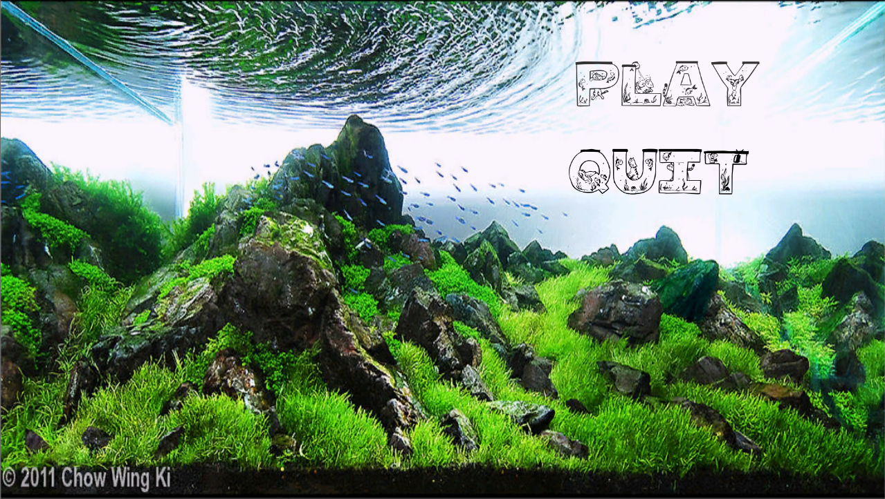

1

2

### Play [1]

This button starts the game and takes the player to the Game Screen.

### Quit [2]

This button closes the application.

## Game Screen

This screen is where the player will create their aquarium and where the gameplay happens.

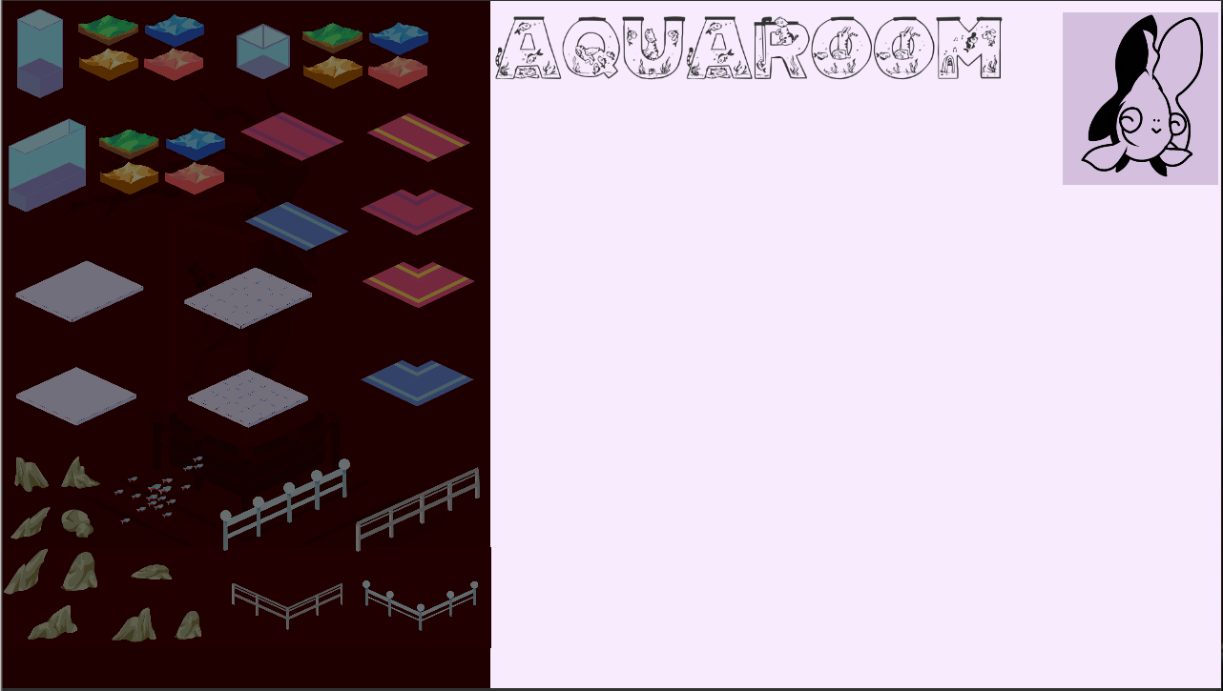

2

4

3

1

### Asset Pane [1]

Contains all the placeable assets in the game. Assets have depth priority so they can be placed down in any order. Selected asset will highlight when clicked to show the player which sprite they are placing.

### Game Title [2]

Clicking this will take the player back to the title screen.

### Reset Fish [3]

Clicking this fish will reset the Game Screen.

### Play Area [4]

This is where the assets can be placed. Assets are placed on mouse click, with only a single instance of each asset being placeable. If an already placed asset is clicked in a different position it will move the asset.

## Assets

This project contains a combination of unique art assets created for this game, and assets found online.

### Audio Assets:

This game borrows some sound clips from Super Mario 64 for the Nintendo 64 because that game was so influential on the students making this project. It also uses the “Royalty Free 2” song from Mattia Cupelli for the Game Screen portion of the game to give the player some ambiance as they make their aquariums.

<http://www.mariomayhem.com/downloads/sound_tracks/super_mario_64_original_soundtrack.php>

* “24 Game Start.mp3”, used on the “Loading Screen”
* “09 Dire, Dire Docks.mp3”, used on the “Title Screen”

<https://soundcloud.com/mattiacupelli/royalty-download-free>

* “Royalty Free 2.wav”, used on the “Game Screen”

### Art Assets:

The Title Screen image is from Chow Wing Ki which was found on Google. It is a beautiful that sets the tone and feel of the game.

### Fonts:

Two fonts were downloaded for this game from, [www.dafont.com](http://www.dafont.com). These two fonts were “Aquarious” and “AQUARIUM”. These fonts were used for the loading screen and the in-game text on the Title Screen and the Game Screen.